1. Aesthetic-Usability Effect ✔️

**Users often perceive aesthetically pleasing design as design that’s more usable.**

* Video Streaming Doesn’t Start With Auto Resolution, Which Makes That Application Slow

1. Doherty Threshold ❌

**Productivity soars when a computer and its users interact at a pace (<400ms) that ensures that neither has to wait on the other.**

* Generating Download Links (Preview Of Video)
* 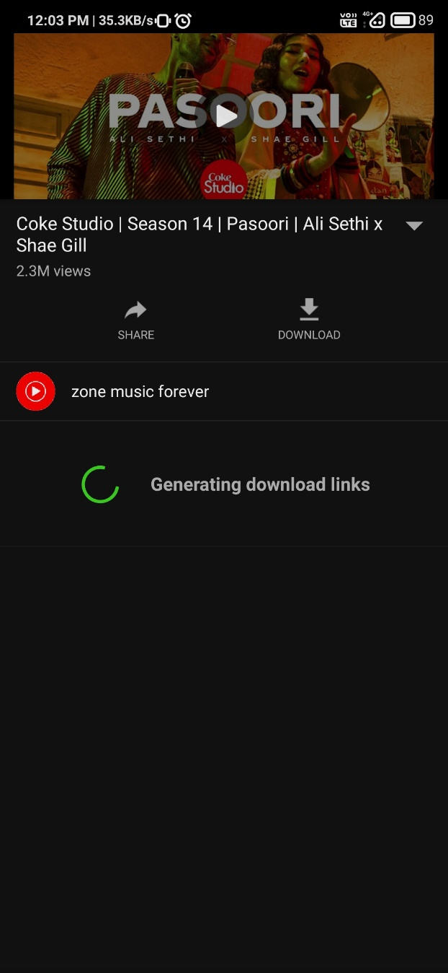

1. Fitts’s Law ✔️

**The time to acquire a target is a function of the distance to and size of the target.**

* Navigation
* **Graphical user interface, application, website

  Description automatically generated**

1. Goal-Oriented Effect ✔️

**The tendency to approach a goal increases with proximity to the goal.**

* Video Duration

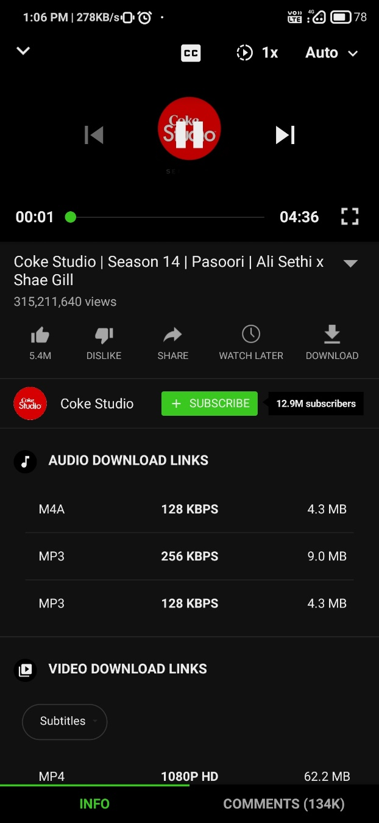

1. Hick’s Law ✔️

**The time it takes to make a decision increases with the number and complexity of choices.**

* Variety
* Graphical user interface, application

  Description automatically generated

1. Jakob’s Law ✔️

**Users spend most of their time on other sites. This means that users prefer your site to work the same way as all the other sites they already know.**

* Youtube

1. Laws of Common Region ✔️

**Elements tend to be perceived into groups if they are sharing an area with a clearly defined boundary.**

* Border Around Particular Video

1. Law of Proximity ✔️

**Objects that are near, or proximate to each other, tend to be grouped together.**

* Videos in close proximity are perceived to share similar functionality or traits

1. Law of Pragnanz ✔️

**People will perceive and interpret ambiguous or complex images as the simplest form possible, because it is the interpretation that requires the least cognitive effort of us.**

* Rectangular And Circular Shapes
* Graphical user interface, application, website

  Description automatically generated

1. Law of Similarity ✔️

**The human eye tends to perceive similar elements in a design as a complete picture, shape, or group, even if those elements are separated.**

* links and navigation systems are visually differentiated from normal text and image elements
* 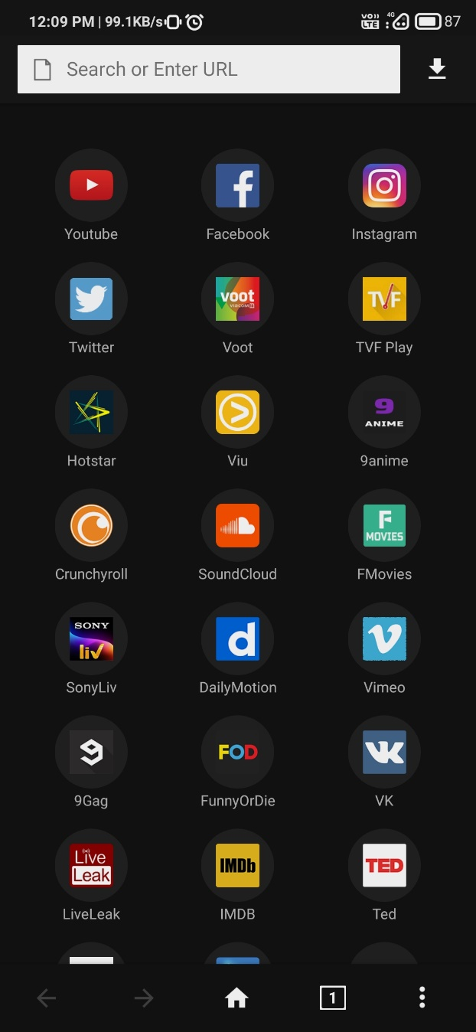

1. Law of Uniform Connectedness ✔️

**Elements that are visually connected are perceived as more related than elements with no connection.**

* Web Apps
* Graphical user interface, website

  Description automatically generated

1. Miller’s Law ✔️

**The average person can only keep 7 (plus or minus 2) items in their working memory.**

* Web Apps

1. Occam’s Razor ✔️

**Among competing hypotheses that predict equally well, the one with the fewest assumptions should be selected.**

* Quick Download & Selection

1. Pareto Principle ✔️

**The Pareto principle states that, for many events, roughly 80% of the effects come from 20% of the causes.**

* Search Bar And Video Recommendations
* 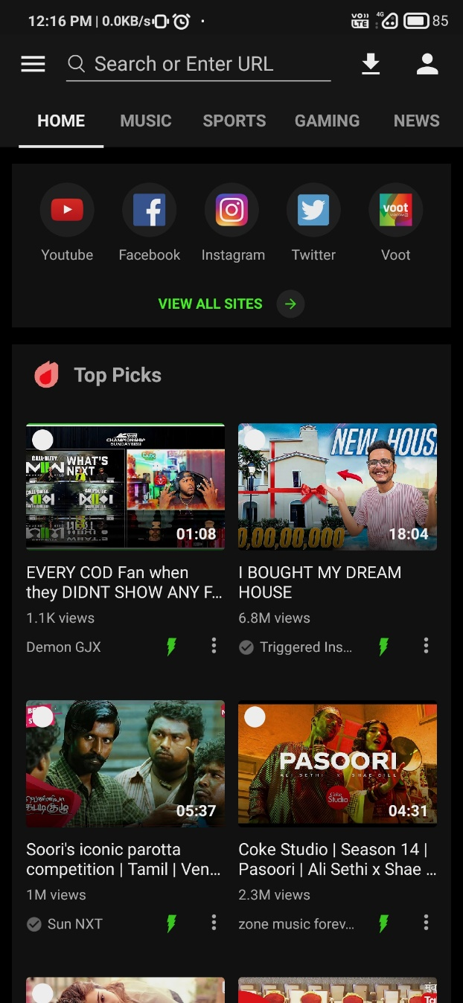

1. Parkinson’s Law ✔️

**Any task will inflate until all of the available time is spent.**

* Limit the time it takes to complete a task (Video Duration)
* A screenshot of a video game

  Description automatically generated with medium confidence

1. Peak-End Rule ✔️

**People judge an experience largely based on how they felt at its peak and at its end, rather than the total sum or average of every moment of the experience.**

* Depends On Video Choice / If Kept For Download And Interrupts
* **Graphical user interface, application

  Description automatically generated**

1. Postel’s Law ✔️

**Be liberal in what you accept, and conservative in what you send.**

* Accept variable input from users (Search URL), translating that input to meet requirements

1. Serial Position Effect ✔️

**Users have a propensity to best remember the first and last items in a series.**

* Placing the least important items in the middle of lists

1. Tesler’s Effect ✔️

**Tesler’s Law, also known as The Law of Conservation of Complexity, states that for any system there is a certain amount of complexity which cannot be reduced.**

* Quick Download Button
* 

1. Von Restorff Effect ✔️

**The Von Restorff effect, also known as The Isolation Effect, predicts that when multiple similar objects are present, the one that differs from the rest is most likely to be remembered.**

* Positioning Of Video (Width)
* **Graphical user interface, website

  Description automatically generated**

1. Zeigarnik Effect ✔️

**People remember uncompleted or interrupted tasks better than completed tasks.**

* Providing artificial progress towards a goal (Downloading/Interrupted Tasks)

